Supplemental Table 1. Amino Acids
Name | Abbreviations | Structure
Glycine | Gly, G | 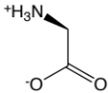
L-Alanine | Ala, A | 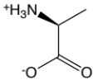
L-Serine | Ser, S | 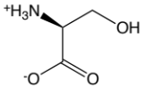
L-Proline | Pro, P | 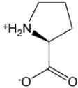
L-Valine | Val, V | 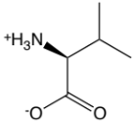
L-Leucine/L-Isoleucine | Leu, L/Ile, I | 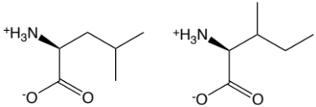
L-Methionine | Met, M | 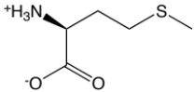
L-Histidine | His, H | 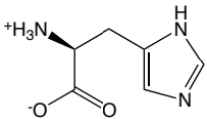
L-Phenylalanine | Phe, F | 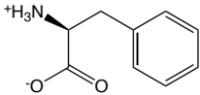
L-Tyrosine | Tyr, Y | 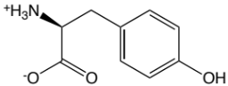
L-Aspartic acid/L-Asparagine | Asx (pooled Asp, D and Asn, N) | 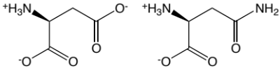
L-Glutamic acid/L-Glutamate | Glx (pooled Glu, E and Gln, Q) | 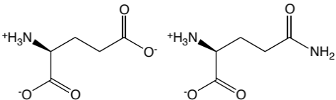
L-Ornithine | Orn | 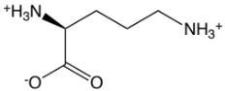
L-Citrulline | Cit, Citr | 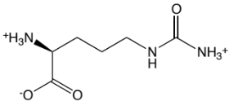
L-Arginine | Arg, R | 